THE CELEBRATION OF OUR CHRISTIAN FAITH
Fort King Presbyterian Church
January 4th, 2026
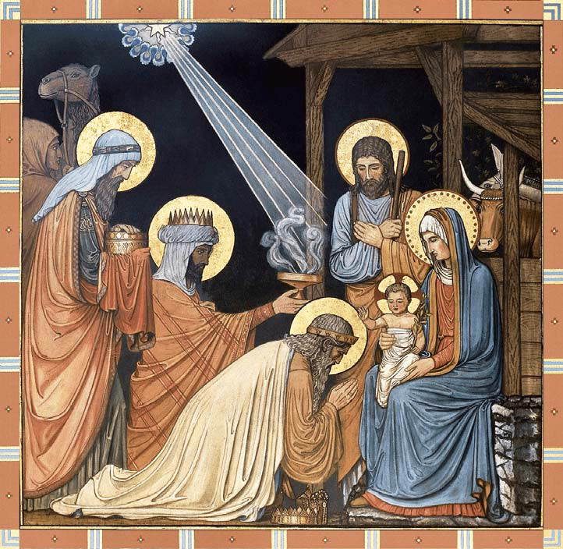
Fort King Presbyterian Church Mission Statement
The mission of Fort King Presbyterian Church is to build a loving community of people living and growing in faith as we work for justice, love mercy, and walk humbly with God in the world. Fort King Presbyterian Church welcomes all people of any age, gender, color, ethnicity, sexual orientation, gender identity, economic status, or disability into the full life and membership of this congregation.

We Gather to Worship God

WELCOME AND ANNOUNCEMENTS

PRELUDE O Come, All Ye Faithful arr. Bill Wolaver

We Prepare to Hear the Word

*CALL TO WORSHIP quotes Isaiah 60:1
Arise! Shine! For your light has come!
And the glory of the Lord has risen upon us!
As this new year dawns may we look for Christ wherever we go,
And may we always reflect the light of Christ to whomever we go.
*HYMN OF PRAISE, #151 We Three Kings of Orient Are KINGS OF ORIENT
(verses 1 and 5)

*PRAYER OF CONFESSION
Dear God, we have just ended a year in which I did not live up to the best
that I know I can be and do.
There were too many times I was short with people and long on criticism.
There were too many times I was quick to judge others but slow to take
responsibility for my own mistakes.
And Lord, too many times I put my trust in myself – and then despaired
because I wasn’t enough – rather than trusting in You, in your wisdom,
your will, and your way!
(Silent prayer of confession)
Heavenly Father, help me to set aside my failures in the past,
accept your forgiveness, and to start out right this new year;
in Jesus’ name. Amen.

*ASSURANCE OF PARDON Isaiah 43:18-19
Remember not the former things, nor consider the things of old.
Behold, I am doing a new thing; even now it springs forth,
Do you not perceive it?

*PASSING THE PEACE
*ACCLAMATION, #151 refrain, We Three Kings of Orient Are KINGS OF ORIENT
O star of wonder, star of night,
star with royal beauty bright,
westward leading, still proceeding,
guide us to thy perfect light!

We Hear the Word of God

OLD TESTAMENT LESSON Isaiah 60:1-6 Arise, Shine, for your Light has Come!

HYMN OF FAITH, #127 Hark, the Herald Angels Sing WE’LL WALK IN THE LIGHT
Jesus, the Light of the World
(verses 1 and 2)
NEW TESTAMENT LESSON Matthew 2:1-12 The Visit of the Magi

SERMON

We Respond to the Word with Gratitude

CHANCEL ANTHEM Born is Emmanuel
PRAYERS OF THE PEOPLE
OFFERING OUR GIFTS AND OURSELVES
OFFERTORY The Sussex Carol Traditional English Melody
*DOXOLOGY, #606 Praise God from Whom All Blessings Flow OLD HUNDRETH
Praise God from whom all blessings flow;
Praise God all creatures here below;
Praise God above, ye heavenly host;
Praise Father, Son, and Holy Ghost. Amen.
*PRAYER OF DEDICATION

The Sacrament of Holy Communion

INVITATION TO THE TABLE
PRAYER OF CONSECRATION
The Lord be with you.
And also with you.
Lift up your hearts!
We light them up to the Lord.
Let us give thanks to the Lord our God.
It is right to give our thanks and praise.

THE LORD’S PRAYER - (“debts”/“debtors”)

THE WORDS OF INSTITUTION
THE BREAD AND CUP
PRAYER OF THANKSGIVING

We Are Sent to Share Christ’s Love

*CLOSING HYMN, #192 Lord, the Light of your Love Is Shining SHINE, JESUS SHINE

*INVITATION AND BENEDICTION
*POSTLUDE
Assisting with Today’s Service:
Fort King Ministers: All our members and friends
Worship Leaders: Pastor Bob, Bernice Henry
Executive Assistant: Mary Wald
Music Director: John Leschak
Flowers: Margaret Spontak
Ushers: December: Daniel Banks & Friends
Zoom Host: Harvey Bohner, A/V Operator: Charlanne & Hal Brown
Nursery: Tammy Kesslar and Marlene Wittenwyler

ANNOUNCEMENTS - for week of January 5th, 2026 – January 11th, 2026
01/05 | Mon: | 6:30 | Scouts (FH/CE)
01/06 | Tue: | 3:30 | Mission Committee (SR), 3:30 TOPS (FH), 4:00 Property (CE)
01/07 | Wed: | 1:00 | Midweek Bible Study (SR), PW Council (SR), 6:30 YAK (Zoom)
01/08 | Thu | 3:00 | Tai Chi (FH), 4:00 Choir Practice
01/11 | Sun: | 9:00 | Crossroads Adult Class
 |  | 10:30 | Worship in person and on Zoom
 |  |  | Share Table

THE SESSION
Moderator: Rev. Bob Scott |  | Clerk of Session: Nancy Copeland
Class of 2026  Daniel Banks  Bernice Henry  Mary Beth Neely  Jo Anne Parramore | Class of 2027  Hal Brown  Judith Bullen  Sally Layendecker  Joanne Ohlman |  | Class of 2028  Steve Barrett  Cathy Beebe  Debbi Pangrass  Sue Thomas

13 NE 36th Avenue • Ocala, FL 34470 • Office: 352-694-4121
Email: FKPC@ftkingchurch.org https://ftkingchurch.org

