THE CELEBRATION OF OUR CHRISTIAN FAITH
Fort King Presbyterian Church
January 11th, 2026
Baptism of the Lord Sunday

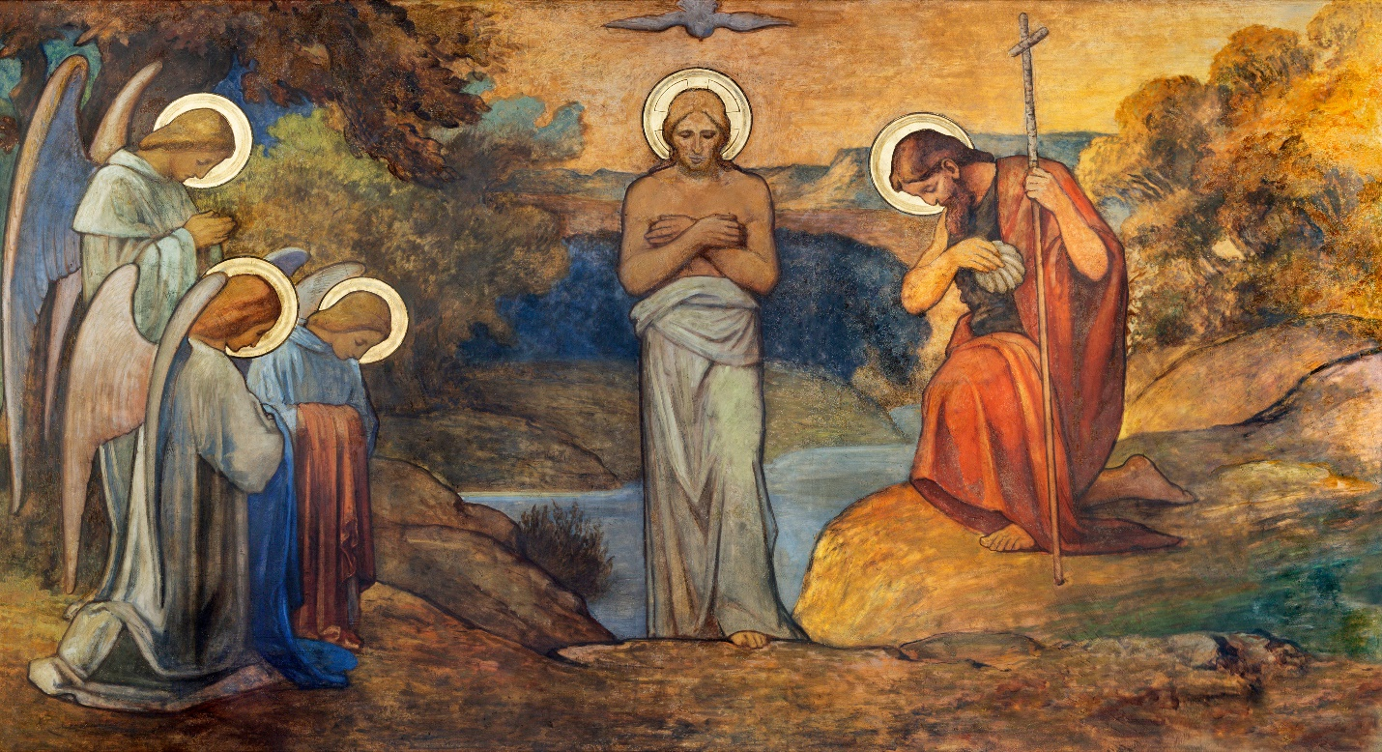

Fort King Presbyterian Church Mission Statement
The mission of Fort King Presbyterian Church is to build a loving community of people living and growing in faith as we work for justice, love mercy, and walk humbly with God in the world. Fort King Presbyterian Church welcomes all people of any age, gender, color, ethnicity, sexual orientation, gender identity, economic status, or disability into the full life and membership of this congregation.

We Gather to Worship God

WELCOME AND ANNOUNCEMENTS
MOMENT FOR MISSION Legacy Project Jon Ohlman
MLK March Daniel Banks

PRELUDE Pass It On by Kurt Kaiser

We Prepare to Hear the Word

*CALL TO WORSHIP Isaiah 42:1 and Matthew 3:16-17
God says:
“Here is my chosen servant,
the One in whom I utterly delight;
I have placed my Spirit on him,
and he will bring true justice to the nations.”
When Jesus was baptized, the heavens opened up,
and the Spirit of God came down like a dove;
and there was a voice from heaven saying:
“This is my dearly loved Son,
with whom I am delighted.”
The joy of the Lord be with you all!
And also with you.
Let us worship God!

*HYMN OF PRAISE, #475 Come, Thou Fount of Every Blessing NETTLETON

*PRAYER OF CONFESSION
Gracious God,
You claim us and call us;
You support us and uphold us,
You save us and free us from our sin.
Yet we slip into old habits,
worshiping the idols that have claimed our hearts,
disregarding our impact on the earth and our neighbors.
Forgive us, we pray.
Meet us at the water again,
that we might know we belong to you.

*ASSURANCE OF PARDON
*PASSING THE PEACE
*RESPONSE, #623, v. 1 I’ve Got Peace like a River PEACE LIKE A RIVER
I’ve got peace like a river; I’ve got peace like a river;
I’ve got peace like a river in my soul.
I’ve got peace like a river; I’ve got peace like a river;
I’ve got peace like a river in my soul.

We Hear the Word of God

FIRST SCRIPTURE LESSON Isaiah 42:1-9 The Servant of the Lord

HYMN OF FAITH, #288 Spirit of the Living God LIVING GOD

SECOND SCRIPTURE LESSON Matthew 3:13-17 The Baptism of Jesus

SERMON Jesus’ Baptism, and Our Own Rev. Bob Scott

We Respond to the Word with Gratitude

ANTHEM Be Kind to One Another Chancel Choir

PRAYERS OF THE PEOPLE
THE LORD’S PRAYER
OFFERING OUR GIFTS AND OURSELVES

OFFERTORY Open Our Eyes Bob Cull

*RESPONSE, #623, v. 2 I’ve Got Joy like a Fountain PEACE LIKE A RIVER
I’ve got joy like a fountain; I’ve got joy like a fountain;
I’ve got joy like a fountain, in my soul.
I’ve got joy like a fountain; I’ve got joy like a fountain;
I’ve got joy like a fountain, in my soul.

*PRAYER OF DEDICATION

Renewal of our Baptismal Vows
WORDS OF GRACE
THE REAFFIRMATION OF OUR FAITH
In the presence of God and this congregation, do you desire to renew the covenant which you have made, or which was made for you, at your baptism?
I do.
Do you renounce evil and seek to walk in the life of faith as a person who trusts in God alone for life, strength and salvation?
I do.
Do you believe that Jesus is the Christ, the Son of the Living God, the Savior of the world; and do you declare him Lord of your life?
I do.
Then let us say together what we believe:
APOSTLES’ CREED
I believe in God the Father Almighty,
maker of heaven and earth.
And in Jesus Christ, his only Son, our Lord;
who was conceived by the Holy Ghost,
born of the Virgin Mary,
suffered under Pontius Pilate,
was crucified, dead, and buried;
he descended into hell;
the third day he rose again from the dead;
he ascended into heaven,
and sitteth on the right hand of God the Father Almighty;
from thence he shall come to judge the quick and the dead.
I believe in the Holy Ghost,
the holy catholic church,
the communion of saints,
the forgiveness of sins,
the resurrection of the body,
and the life everlasting. Amen.

PRAYER OVER THE WATER
REMEMBERING GOD’S CLAIM ON OUR LIVES
Remember you are baptized and be thankful.
In the name of the Father and the Son and the Holy Spirit.

We Are Sent to Share Christ’s Love

*CLOSING HYMN, #623, v. 3 I’ve Got Love like an Ocean PEACE LIKE A RIVER
I’ve got love like an ocean; I’ve got love like an ocean;
I’ve got love like an ocean, in my soul.
I’ve got love like an ocean; I’ve got love like an ocean;
I’ve got love like an ocean, in my soul.

*INVITATION AND BENEDICTION
*POSTLUDE

[* indicates all should rise in body, or in spirit]

Assisting with Today’s Service:
Fort King Ministers: All our members and friends
Worship Leaders: Pastor Bob, Cathy Beebe
Executive Assistant: Mary Wald
Music Director: John Leschak
Ushers: January: Daniel Banks & Friends
Zoom Host: Hal Brown, A/V Operator: Sally Layendecker
Nursery: Tammy Kesslar and Marlene Wittenwyler
Art: Fresco of Baptism of Jesus, Prague, Czech Republic, (1900); Shutterstock.com

ANNOUNCEMENTS - for week of January 12th, 2026 – January 18th, 2026
01/12 | Mon: | 3:00 | Fellowship Ministry (SR), 4:00 Esther Circle (SR & Zoom),  6 :30 Scouts (FH/CE)
01/13 | Tue: | 2:00 | Congregational Care (SR), TOPS (FH)
01/14 | Wed: | 1:00 | Midweek Bible Study (SR), 4:00 Finance Ministry
01/15 | Thu | 3:00 | Tai Chi (FH), 4:00 Legacy (SR), 4:00 Choir Practice
01/18 | Sun: | 9:00 | Crossroads Adult Class
 |  | 10:30 | Worship in person and on Zoom
 |  | 2:00 | Art 4 All

Join us today and participate in the Share Table after Worship Service.

Annual Congregational Meeting Notice
Our annual congregational meeting is scheduled for January 25th, immediately following the worship service. At this meeting we will review the year just past; look at how the year finished financially and discuss this year’s budget. We will also hear a report from the Nominating Committee and elect one new elder and representatives to next year’s Nominating Committee.
We do ask all members to make every effort to attend, and of course, all our visitors and friends of Fort King are welcome and encouraged to stay.

THE SESSION
Moderator: Rev. Bob Scott |  | Clerk of Session: Nancy Copeland
Class of 2026  Daniel Banks  Bernice Henry  Mary Beth Neely  Jo Anne Parramore | Class of 2027  Hal Brown  Judith Bullen  Sally Layendecker  Joanne Ohlman |  | Class of 2028  Steve Barrett  Cathy Beebe  Debbi Pangrass  Sue Thomas

13 NE 36th Avenue • Ocala, FL 34470 • Office: 352-694-4121
Email: FKPC@ftkingchurch.org https://ftkingchurch.org

