THE CELEBRATION OF OUR CHRISTIAN FAITH
Fort King Presbyterian Church
January 25th, 2026

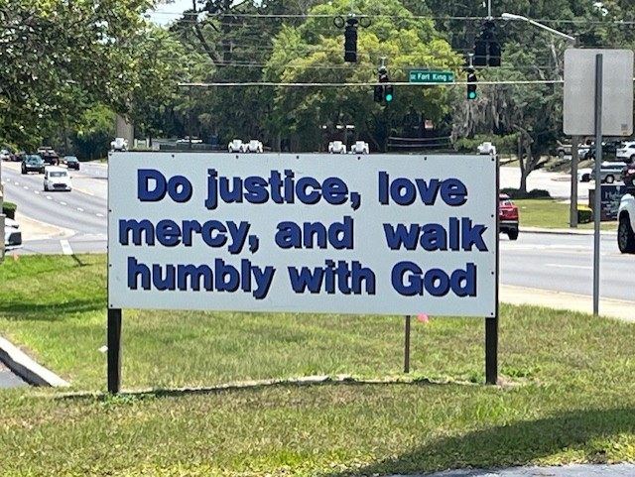

Fort King Presbyterian Church Mission Statement
The mission of Fort King Presbyterian Church is to build a loving community of people living and growing in faith as we work for justice, love mercy, and walk humbly with God in the world. Fort King Presbyterian Church welcomes all people of any age, gender, color, ethnicity, sexual orientation, gender identity, economic status, or disability into the full life and membership of this congregation.

We Gather to Worship God

WELCOME AND ANNOUNCEMENTS
MOMENT FOR MISSION Legacy Seminar Sally Layendecker
Legacies of Love with Interfaith Mary Beth Neely

PRELUDE Jesus, Name Above All Names Naida Hearn

We Prepare to Hear the Word

*CALL TO WORSHIP
Fort King Faithful, God has shown us what is good.
To do justice, to love kindness, and to walk humbly with our God.
Jesus calls us deeper still: “You have heard it said… but I say to you…”
Transform our ways, O Christ. Shape our lives from the inside out.
Let us gather to hear Christ’s teaching, to walk in God’s justice,
and to worship the One who leads us in the way of life.

*HYMN OF PRAISE, #835 Just a Closer Walk with Thee CLOSER WALK
(refrain, verses 1-2, refrain)

*PRAYER OF CONFESSION
How often we make the wrong choices, God of our lives!
We view others through prisms of lust or fear, distorting who they really are.
We toss about harmful words like seashells scattered after a storm.
We would rather insult those around us than to lift them up.
And we feed on our anger, bitterness and hurt.
Have mercy on us, God who is everywhere!
May we set aside our quarreling natures to be united
in common worship, common service, and a common purpose,
as we follow Jesus Christ, the One who is our Lord and Savior. Amen.

*ASSURANCE OF PARDON
*PASSING THE PEACE
*RESPONSE, #835 Just a Closer Walk with Thee Refrain
Just a closer walk with Thee, grant it, Jesus, is my plea;
Daily walking close to thee: let it be, dear Lord, let it be.

We Hear the Word of God

FIRST SCRIPTURE LESSON Micah 6:6-8 What God Requires

HYMN OF FAITH, #70 What Does the Lord Require of You? MOON
(repeat)
SECOND SCRIPTURE LESSON Matthew 5:17-48 “But I Say to You…”
selected verses

SERMON A Vision for the Church and the World Rev. Bob Scott
(On the Mountain with the Messiah, Part 2)

We Respond to the Word with Gratitude

*ANTHEM Heard About a Newborn The Chancel Choir

PRAYERS OF THE PEOPLE
THE LORD’S PRAYER
OFFERING OUR GIFTS AND OURSELVES

OFFERTORY He Is Exalted Twila Paris

*RESPONSE, #450, v. 3 Be Thou My Vision SLANE
Riches I heed not, nor vain, empty praise;
Thou mine inheritance, now and always;
Thou and thou only, first in my heart,
High King of Heaven, my treasure thou art.

*PRAYER OF DEDICATION

We Are Sent to Share Christ’s Love

*CLOSING HYMN, #450 Be Thou My Vision SLANE
(verses 1, 2 and 4)

*INVITATION AND BENEDICTION
*POSTLUDE

ANNUAL CONGREGATIONAL MEETING
We request all members stay for the Congregational Meeting
immediately following today’s worship service.
All visitors and friends of Fort King are also welcome to stay!

[* indicates all should rise in body, or in spirit]

Assisting with Today’s Service:
Fort King Ministers: All our members and friends
Worship Leaders: Pastor Bob, Matthew Kemnitz
Executive Assistant: Mary Wald
Music Director: John Leschak
Ushers: January: Daniel Banks & Friends
Zoom Host: Ken McMurry, A/V Operator: Lorraine Fuller
Nursery: Tammy Kesslar and Marlene Wittenwyler

ANNOUNCEMENTS - for week of January 26th, 2026 – February 1st, 2026
01/26 | Mon: | 1:30 | Caravan for 2-3:00 Camellia Tour, 6 :30 Scouts (FH/CE)
01/27 | Tue: | 3:30 | TOPS (FH)
01/28 | Wed: | 1:00 | Midweek Bible Study (SR),
01/29 | Thu | 7:00 | BNI (FH), 3:00 Tai Chi (FH), 4:00 Choir Practice
02/01 | Sun: | 9:00 | Crossroads Adult Class
 |  | 10:30 | Worship in person and on Zoom
 |  | 2:00 | Equal Exchange  Camellia Society (FH)

Join us for the Annual Congregational Meeting
Our annual congregational meeting immediately follows the worship service today, January 25th. At this meeting we will review the year just past; look at how the year finished financially and discuss this year’s budget. We will also hear a report from the Nominating Committee and elect one new elder and representatives to next year’s Nominating Committee.

We do ask all members to make every effort to attend, and of course,
all our visitors and friends of Fort King are welcome and encouraged to stay.

Enjoy the MacKay Annual Camellia Tour
Monday, January 26th, 2-3:00 – 1:30 Caravan from church
THE SESSION
Moderator: Rev. Bob Scott |  | Clerk of Session: Nancy Copeland
Class of 2026  Daniel Banks  Bernice Henry  Mary Beth Neely  Jo Anne Parramore | Class of 2027  Hal Brown  Judith Bullen  Sally Layendecker  Joanne Ohlman |  | Class of 2028  Steve Barrett  Cathy Beebe  Debbi Pangrass  Sue Thomas

Please remember to include Ft. King Presbyterian Church in your Will and Estate Plan. Thank you!
13 NE 36th Avenue • Ocala, FL 34470 • Office: 352-694-4121
Email: FKPC@ftkingchurch.org https://ftkingchurch.org

