THE CELEBRATION OF OUR CHRISTIAN FAITH
Fort King Presbyterian Church
March 15th, 2026
The Fourth Sunday in Lent

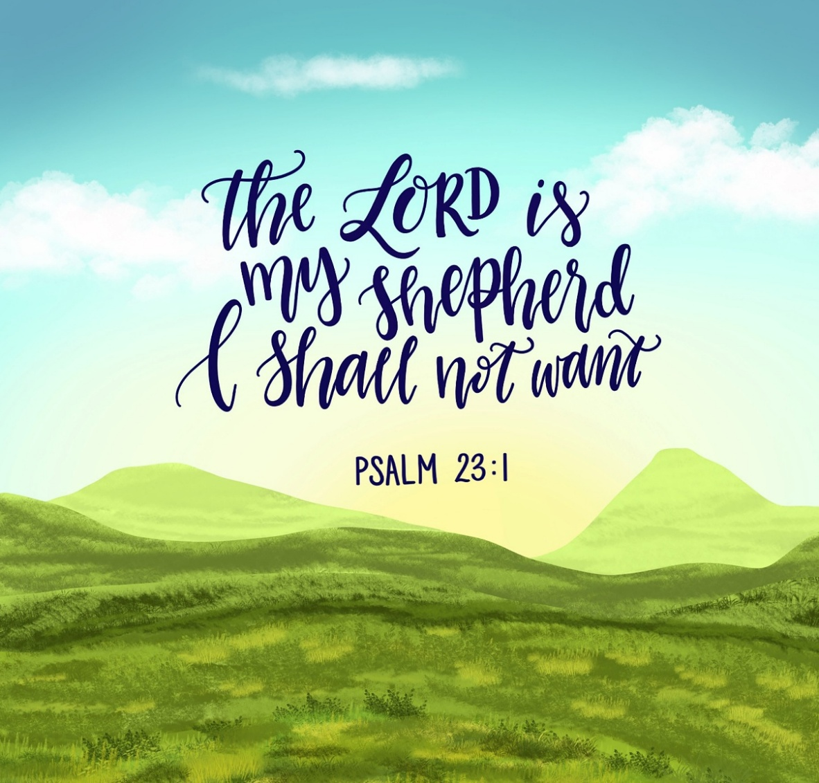

Fort King Presbyterian Church Mission Statement
The mission of Fort King Presbyterian Church is to build a loving community of people living and growing in faith as we work for justice, love mercy, and walk humbly with God in the world. Fort King Presbyterian Church welcomes all people of any age, gender, color, ethnicity, sexual orientation, gender identity, economic status, or disability into the full life and membership of this congregation.

We Gather to Worship God

WELCOME AND ANNOUNCEMENTS
MOMENTS for MINISTRY Easter Egg Hunt Bernice Henry & Harvey Bohner

PRELUDE Just As I Am Wm Bradbury

We Prepare to Hear the Word

*CALL TO WORSHIP
When the world is dark and full of hate and fear, when we cannot see God
we will turn on the light.
When we cannot find our way back to love and peace
we will turn on the light.
When our vision dims due to the darkness within
we will turn on the light.
Christ opens our eyes with the gift of sight.
The light of the world is Jesus Christ.
Come and worship the one who brings sight to the blind.
Hallelujah! Praise God, the light of the world!

*HYMN OF PRAISE, #450 Be Thou My Vision

*CALL TO RECONCILLIATION

*PRAYER OF CONFESSION
Forgiving God, in a world filled with so much pain, we would rather shut our eyes and be blind than see things as they really are. Grant us the courage to face the reality of our world, and give us the strength to bring Your light to those who walk in darkness. Help us see others as You see them, and forgive us when we do not trust You enough to open our eyes to the possibilities before us. Heal our self-inflicted blindness, O God, and lead us in the footsteps of the Light of the World, who reveals Your glory in His life, His teachings, and His love.
In His holy name, we pray. Amen.

*ASSURANCE OF PARDON
We Hear the Word of God

PRAYER FOR ILLUMINATION

FIRST READING Psalm 23

ANTHEM Be Kind to One Another Chancel Choir

SECOND READING John 9: 1-41

SERMON What if We Could See the Way God Sees? Debbie Pangrass

We Respond to the Word with Gratitude

*AFFIRMATION OF FAITH Rev. Bruce Prewer
I believe I need a shepherd: Because I am sometimes timid and other times overconfident, because I often don't know the best path yet pretend I do, because I rush into dead ends or lead others into hazardous places, because my brightest ideas are seamed with darkness, because the things I crave may not be what is good for me, I need a shepherd.

I believe in Jesus, the best possible shepherd; His wisdom leads me to the best opportunities, His word comforts me when I'm anxious or afraid, His arm steadies me when I feel weary and heavy-laden, His wounded body displays the cost of my rescue, I believe in Jesus, the best possible shepherd.

I believe that I do not find Him but he finds me, that I under His care by virtue of sheer grace, the love He gives me is to be shared with others, that He treasures my name and prepares a place for me, that His fold transfixes earth and heaven. I trust Jesus, the good shepherd. Amen.

*HYMN OF FAITH, #451 Open My Eyes, That I May See

PRAYERS OF THE PEOPLE

OFFERING OUR GIFTS AND OURSELVES

OFFERTORY I Surrender All arr. Fred Bock

*DOXOLOGY

*PRAYER OF DEDICATION

We Are Sent to Share Christ’s Love

*HYMN of PARTING, #853 We Are Marching in the Light of God
(sing twice)

* BENEDICTION
*POSTLUDE

[* indicates all should rise in body, or in spirit]

Assisting with Today’s Service:
Fort King Ministers: All our members and friends
Worship Leaders: Debbie Pangrass, Harvey Bohner
Executive Assistant: Mary Wald
Music Director: John Leschak
Ushers: March: Missions
Flowers: Nancy Copeland in Memory of Jim and our son, Scott
Zoom Host: Hal Brown, A/V Operator: Jon Ohlman
Nursery: Tammy Kesslar and Marlene Wittenwyler

ANNOUNCEMENTS - for week of March 16th, 2026 – March 22nd, 2026
03/16 | Mon: | 6:30 | Scouts (FH/CE)
03/17 | Tue: | 3:30 | TOPS (FH), 4:30 Pearl Project Caregiver Training (FH),  6:30 PNC Meeting (SR)
03/18 | Wed: | 1:00 | Midweek Bible Study (SR), 6:30 Session
03/19 | Thu: | 7:00 | Legacy Allies [BNI] (FH), 2:00 Finance (SR),  3:00 Tai Chi (FH), 4:00 Choir Practice
03/22 | Sun: | 9:00 | Crossroads Adult Class (SR)
 |  | 10:30 | Worship in person and on Zoom with Guest Pastor Debbie Pangrass
 |  |  | Hearts & Hands
 |  | 12:00 | Joint Memorial Service

~~~ Join us this afternoon for Art 4 All 2:00-5:00 ~~~

This Lenten Season
Invite a friend to church and bring a non-perishable food item for the Interfaith Food Bank.


Joint Memorial Service, Sunday, March 22
Over the last few months we have had several members pass away:
Fran York, Roselle Pringle, Penny Stample, and Betty Cluster.


Following worship on Sunday, March 22, we will hold a brief Memorial Service in the sanctuary in their honor. This simple service of remembrance will offer space for prayer, gratitude, and shared grief as we commend their lives to God’s eternal care. The service will begin at 12:00 noon, and will last no more than half-an-hour. All are welcome to stay and join us as we give thanks for their witness and entrust their memory to the One who holds us in life and in death.

13 NE 36th Avenue • Ocala, FL 34470 • Office: 352-694-4121
Email: FKPC@ftkingchurch.org https://ftkingchurch.org

