THE CELEBRATION OF OUR CHRISTIAN FAITH
Fort King Presbyterian Church
March 22nd, 2026
The Fifth Sunday in Lent

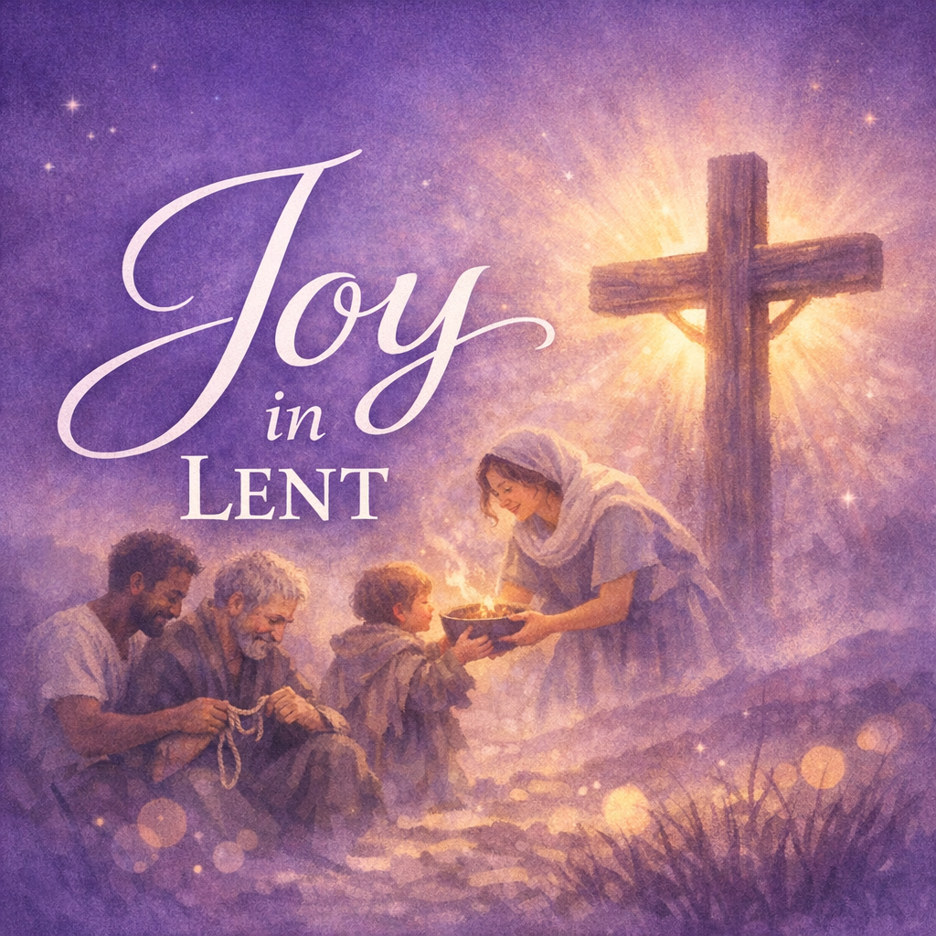

Fort King Presbyterian Church Mission Statement
The mission of Fort King Presbyterian Church is to build a loving community of people living and growing in faith as we work for justice, love mercy, and walk humbly with God in the world. Fort King Presbyterian Church welcomes all people of any age, gender, color, ethnicity, sexual orientation, gender identity, economic status, or disability into the full life and membership of this congregation.

We Gather to Worship God

WELCOME AND ANNOUNCEMENTS
MOMENTS for MINISTRY Maundy Thursday Dinner Sue Thomas

PRELUDE The Old Rugged Cross George Bennard
We Prepare to Hear the Word

*CALL TO WORSHIP Mark 8:34-35
Jesus calls to us, “If any wish to be my disciple,
let them deny themselves, take up the cross, and follow me.”
Choosing Christ, we receive more – more mercy, more clarity, more joy!
Jesus implores us, “by trying to hang on to your life you will lose it,
but by giving up your life for me and my gospel, you will save it.”
We choose the path of Christ, trusting that losing our lives for his sake
is the way we will find the life that we truly long for!
Come, let us worship the God who leads us into freedom and fullness.
We lift high the cross, and we lift our hearts in praise.

*HYMN OF PRAISE, #826 Lift High the Cross CRUCIFER

*CALL TO CONFESSION Isaiah 58:6
Is this not the fast that I choose: to loose the bond of injustice,
and to let the oppressed go free?
*PRAYER OF CONFESSION
Holy God, you call us to loosen the chains that bind, to share our bread with the hungry, to lift the burdens we place on one another. Yet we confess that we cling
to our own comfort and guard our own interests first.
You invite us to follow Jesus on the path of self-giving love, to take up the cross
rather than grasp for gain. Yet we confess that we resist the way of sacrifice and
fear the simplicity that sets us free.
Forgive us, O Lord. Strip away what is false and heavy within us. Lighten our
steps, that we may walk in your joy, receive your healing, and discover the life
that is truly life; in Christ, we pray. Amen.

*ASSURANCE OF PARDON Matthew 11:28-29
Come to me all who are weary and heavy laden, and I will give you rest.
*PASSING THE PEACE
*RESPONSE #447 We are Forgiven WE ARE FORGIVEN
We are forgiven. We are forgiven.
Thanks be to God. Thanks be to God.
We are forgiven. We are forgiven.
Thanks be to God. Thanks be to God.

We Hear the Word of God

FIRST SCRIPTURE LESSON Isaiah 58:1-9a The Fast God Chooses

HYMN OF FAITH ‘Tis the Gift to Be Simple SIMPLE GIFTS
‘Tis the gift to be simple, ‘tis the gift to be free.
‘Tis the gift to come down where we ought to be;
And when we find ourselves in the place just right,
‘Twill be in the valley of love and delight.
When true simplicity is gained,
to bow and to bend we shan’t be ashamed;
to turn, turn, will be our delight,
Till be turning, turning we come round right.

SECOND SCRIPTURE LESSON Mark 8:34-38 The Way to True Life

SERMON Joy in Simplicity: Choosing Less to Receive More Rev. Bob Scott
(Joy, in Lent? – 5)

We Respond to the Word with Gratitude

RECEPTION OF NEW MEMBER Brian Stoothoff & Lanier and Lucresia Deal
AFFIRMATION OF FAITH
I believe in God the Father Almighty, Maker of heaven and earth.
And in Jesus Christ, his only Son, our Lord; who was conceived by the Holy Ghost, born of the virgin Mary; suffered under Pontius Pilate; was cruciﬁed, dead, and buried; he descended into hell; the third day He arose again from the dead; he ascended into heaven, and sitteth at the right hand of God the Father Almighty; from thence he shall
come to judge the quick and the dead.
I believe in the Holy Ghost; the holy catholic church; the communion of saints; the
forgiveness of sins; the resurrection of the body; and the life everlasting. Amen.

ANTHEM The Love of God Will Find You Chancel Choir

PRAYERS OF THE PEOPLE
THE LORD’S PRAYER

OFFERING OUR GIFTS AND OURSELVES

OFFERTORY Jesus Walked this Lonesome Valley American Folk Song

*RESPONSE, #606 Doxology OLD HUNDRETH
Praise God, from whom all blessings flow;
Praise God, all creatures here below;
Praise God, above, ye heavenly host;
Praise Father, Son, and Holy Ghost. Amen.

*PRAYER OF DEDICATION
We Are Sent to Share Christ’s Love

*CLOSING HYMN, #724 O Jesus, I Have Promised ANGEL’S STORY

*INVITATION AND BENEDICTION
*POSTLUDE

[* indicates all should rise in body, or in spirit]

Assisting with Today’s Service:
Fort King Ministers: All our members and friends
Worship Leaders: Pastor Bob Scott, Bob Schlegel
Executive Assistant: Mary Wald
Music Director: John Leschak
Ushers: March: Missions
Flowers: Anonymous, in the memory of those recently passed.
Zoom Host: Jon Ohlman, A/V Operator: Harvey Bohner
Nursery: Tammy Kesslar and Marlene Wittenwyler
ANNOUNCEMENTS - for week of March 23rd, 2026 – March 29th, 2026
03/23 | Mon: | 6:30 | Scouts (FH/CE)
03/24 | Tue: | 3:30 | TOPS (FH), 5 :15 Pearl Project Caregiver Training (FH),  6:30 PNC Meeting (SR)
03/25 | Wed: | 1:00 | Midweek Bible Study (SR)
03/26 | Thu: | 7:00 | Legacy Allies [BNI] (FH), 3:00 Tai Chi (FH), 4:00 Choir Practice
03/27 | Fri: | 4:00 | -7:00 Spring Garage/Craft Sale Set Up (FH)
03/28 | Sat: | 8:00 | -3:00 Spring Garage/Craft Sale (FH)
03/29 | Sun: | 9:00 | Crossroads Adult Class (SR)
 |  | 10:30 | Worship in person and on Zoom

Hearts and Hands Today

This Lenten Season
Invite a friend to church and bring a non-perishable food item for the Interfaith Food Bank.


Joint Memorial Service, today after Worship
Over the last few months, we have had several members pass away:
Fran York, Roselle Pringle, Penny Stample, and Betty Cluster.


Following worship today, we will hold a brief Memorial Service in the sanctuary in their honor. This simple service of remembrance will offer space for prayer, gratitude, and shared grief as we commend their lives to God’s eternal care. All are welcome to stay and join us as we give thanks for their witness and entrust their memory to the One who holds us in life and in death.

13 NE 36th Avenue • Ocala, FL 34470 • Office: 352-694-4121
Email: FKPC@ftkingchurch.org https://ftkingchurch.org

