THE CELEBRATION OF OUR CHRISTIAN FAITH
Fort King Presbyterian Church
April 12th, 2026
The Sunday after Easter + Bright Sunday

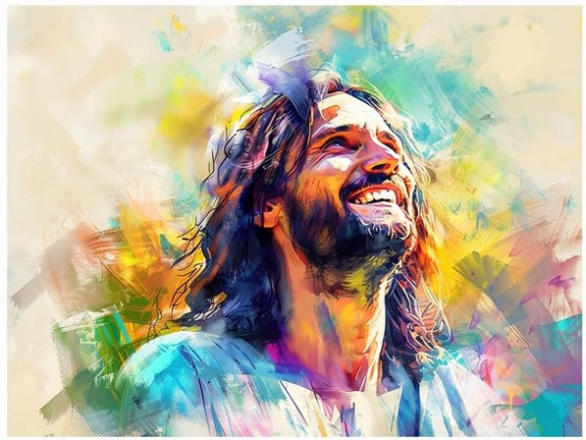

Upon Entering the Sanctuary
For centuries in Eastern Orthodox countries, the week following Easter has been called “Bright Week,”
and the Sunday following Easter called “Bright Sunday." This period was observed by the faithful as
"days of joy and laughter" with parties and feasting in celebration of Jesus' resurrection.
The custom was rooted in the musings of early church theologians (like Gregory of Nyssa, and
John Chrysostom) that God played a practical joke on the devil by raising Jesus from the dead.
the early theologians called it – "Risus paschalis - the Easter laugh!"

We Gather to Worship God

WELCOME AND ANNOUNCEMENTS
MOMENT FOR MISSION Pearl Project Joy & Stephen Zedler

PRELUDE He Touched Me Wm. Gaither

We Prepare to Hear the Word

*CALL TO WORSHIP refers to Psalm 126
When the LORD restored the fortunes of Zion, we were like those who dream.
Then our mouth was filled with laughter, and our tongue with shouts of joy.
When the Lord raised Jesus from the dead, we were like those who dream.
Now our mouths are filled with laughter, and our tongues with shouts of joy.
The Lord has done great things for us, and we rejoice.
May all those who have sowed in tears reap with songs of joy!

*HYMN OF PRAISE, #157 I Danced in the Morning LORD OF THE DANCE

*PRAYER OF CONFESSION
God of resurrection joy, you laugh at the powers of death,
yet we confess how often we let fear have the punchline.
You roll away stones, but we cling to what is heavy and familiar.
You invite us into the surprising freedom of Easter,
yet we return to old worries, old grudges, old habits
as though the tomb were still sealed.
Forgive us for living small lives
when You have opened wide the door to life.
Forgive us for forgetting that grace is stronger than guilt,
hope is stronger than despair, and joy is stronger than any shadow.
Let the Easter laughter rise in us until our lives echo the good news:
Christ is risen! Christ is risen indeed! Amen.

*ASSURANCE OF PARDON
*PASSING THE PEACE
*RESPONSE #243 Be Not Afraid BE NOT AFRAID
Be not afraid; sing out for joy! Christ is risen, alleluia!
Be not afraid; sing out for joy! Christ is risen, alleluia!

We Hear the Word of God

FIRST SCRIPTURE LESSON 1 Corinthians 1:18-30 The Foolishness of the Cross

HYMN OF FAITH, #14 For the Beauty of the Earth DIX
(verses 1, 2, 4, and 5)
SECOND SCRIPTURE LESSON John 20:19-31 Jesus appears to “Doubting” Thomas

SERMON Laugh, Thomas, Laugh! Rev. Bob Scott
We Respond to the Word with Gratitude

BRIGHT SUNDAY AFFIRMATION
We believe in God, who made us in God’s very own image.
We live, we love, we laugh, because we are like God!
We believe in Jesus Christ, our Lord and Savior.
Jesus had the last laugh on the devil when he rose from the dead
We believe in the Holy Spirit, coequal and coeternal with the Father and the Son.
Our counselor, our guide, our motivator – she is our joy! Amen.

*ANTHEM Jesus is All the World to Me Chancel Choir

PRAYERS OF THE PEOPLE
THE LORD’S PRAYER
OFFERING OUR GIFTS AND OURSELVES
OFFERTORY Come, Holy Spirit Wm. Gaither
*RESPONSE, #609 Doxology (with Alleluias) LASST UNS ERFREUEN
Praise God from whom all blessings flow,
Praise God all creatures here below,
Alleluia! Alleluia!
Praise God above ye heavenly host,
Praise Father, Son, and Holy Ghost,
Alleluia! Alleluia! Alleluia!
Alleluia! Alleluia!

*PRAYER OF DEDICATION

We Are Sent to Share Christ’s Love

*CLOSING HYMN, #250 In the Bulb There Is a Flower HYMN OF PROMISE

*INVITATION AND BENEDICTION
*POSTLUDE

[* indicates all should rise in body, or in spirit]

Assisting with Today’s Service:
Fort King Ministers: All our members and friends
Worship Leaders: Pastor Bob Scott, Margaret Spontak
Executive Assistant: Mary Wald
Music Director: John Leschak
Ushers: March: Worship
Zoom Host: John Ohlman, A/V Operator: Lorraine Fuller
Nursery: Tammy Kesslar and Marlene Wittenwyler

ANNOUNCEMENTS - for week of April 13th, 2026 – April 19th, 2026
04/13 | Mon: | 3:00 | Fellowship (SR), 4:00 Esther’s Circle (SR), 6:30 Scouts (FH/CE)
04/14 | Tue: | 10:00  5:30  6:30 | Chair Yoga (FH), 2:00 Cong. Care (SR)  Pearl Project Caregiver Training, 3:30 TOPS (FH)  PNC Meeting (SR)
04/15 | Wed: | 1:00 | Midweek Bible Study (SR), 6:30 Session (SR)
04/16 | Thu: | 7:00  3:00 | Legacy Allies [BNI] (FH), 2:00 Finance (SR)  Tai Chi (FH), 4:00 Choir Practice
04/18 | Sat: | 8:00 | -12:00 Clean Up Day
04/19 | Sun: | 9:00 | Crossroads Adult Class (SR)
 |  | 10:30 | Easter Sunday Worship in person and on Zoom
 |  | 2:00 | -5:00 Art 4 All

Join us at the Share Table in the Narthex Today

Fort King Presbyterian Church Mission Statement
The mission of Fort King Presbyterian Church is to build a loving community of people living and growing in faith as we work for justice, love mercy, and walk humbly with God in the world. Fort King Presbyterian Church welcomes all people of any age, gender, color, ethnicity, sexual orientation, gender identity, economic status, or disability into the full life and membership of this congregation.

Please remember to include Ft. King Presbyterian Church in your Will and Estate Plan. Thank you!

13 NE 36th Avenue • Ocala, FL 34470 • Office: 352-694-4121
Email: FKPC@ftkingchurch.org https://ftkingchurch.org

