THE CELEBRATION OF OUR CHRISTIAN FAITH
Fort King Presbyterian Church
May 3rd, 2026

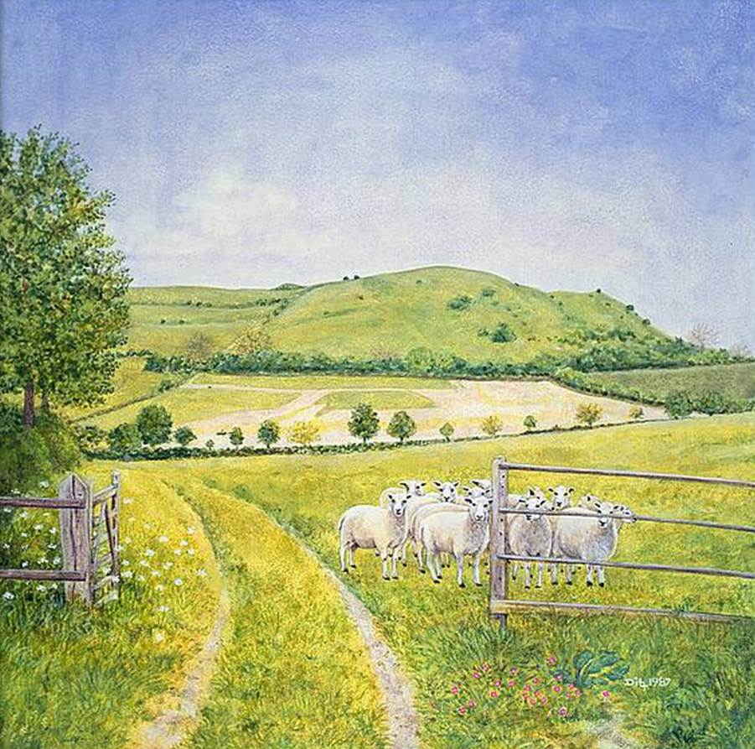

Fort King Presbyterian Church Mission Statement
The mission of Fort King Presbyterian Church is to build a loving community of people living and growing in faith as we work for justice, love mercy, and walk humbly with God in the world. Fort King Presbyterian Church welcomes all people of any age, gender, color, ethnicity, sexual orientation, gender identity, economic status, or disability into the full life and membership of this congregation.

We Gather to Worship God

WELCOME AND ANNOUNCEMENTS
MOMENT FOR MISSION OGHS Thank You Annette George

PRELUDE At the Cross arr. Richard Huggins
We Prepare to Hear the Word

*CALL TO WORSHIP Psalm 23
The Lord is my Shepherd;
I shall not want.
He makes me lie down in green pastures,
and leads me beside still waters;
He restores my soul,
and guides me along right paths for his name’s sake.
Even though I walk through the darkest valley,
I will not fear, for you are close beside me.
Your rod and your staff, they comfort me.
You prepare a table before me in the presence of my enemies;
You anoint my head with oil;
My cup overflows.
Surely goodness and mercy shall follow me
all the days of my life;
And I will dwell in the house of the Lord forever.

*HYMN OF PRAISE, #187 Savior, like a Shepherd Lead Us BRADBURY
(verses 1-3)

*PRAYER OF CONFESSION
Holy Shepherd, you call us by name, yet we confess that we have not always listened for your voice. You lead us toward still waters and safe pastures, yet we wander after lesser paths that cannot give life. You offer protection, guidance, and care, yet we cling
to our own ways, trusting our instincts more than your wisdom.
Forgive us for the times we have ignored the needs of others, choosing comfort over compassion. Forgive us when fear scatters us, when pride isolates us, and when stubbornness keeps us from returning to your side. Gather us in your mercy, restore our souls, and teach us again to follow the One who lays down his life for the sheep, so that we may walk in your goodness and dwell in your love all our days. Amen.

*ASSURANCE OF PARDON 1 Peter 2:25
“For you were going astray like sheep, but now you have returned
to the shepherd and guardian of your souls.”
*PASSING THE PEACE
*RESPONSE #187, v. 4 BRADBURY
Early let us seek your favor; early let us do your will.
Blessed Lord and only Savior, with your love our spirits fill.
Blessed Jesus, blessed Jesus, you have loved us; love us still.
Blessed Jesus, blessed Jesus, you have loved us; love us still.
We Hear the Word of God

FIRST SCRIPTURE LESSON John 10:1-10 Jesus says, “I Am the Gate for the Sheep”

HYMN OF FAITH, #721 Lord, You Have Come to the Lakeshore PESCADORE DE HOMBRES
(verses 1, 3 and 4)

SECOND SCRIPTURE LESSON John 21:12-17 Jesus says, “Feed my Sheep”

SERMON “I Am the Gate” – We Are the Shepherds Rev. Bob Scott
(“I Am” and We Are – Part 1)

We Respond to the Word with Gratitude

ANTHEM Come to the Table Allen Pote

PRAYERS OF THE PEOPLE
OFFERING OUR GIFTS AND OURSELVES
OFFERTORY Commune with Me arr. Carol Tornquist

*RESPONSE, #606 Doxology OLD HUNDRETH
Praise God, from whom all blessings flow;
Praise God, all creatures here below;
Praise God, above, ye heavenly host;
Praise Father, Son, and Holy Ghost. Amen.

*PRAYER OF DEDICATION

The Sacrament of Holy Communion

INVITATION TO THE TABLE
PRAYER OF CONSECRATION
The Lord be with you.
And also with you.
Lift up your hearts!
We lift them up to the Lord.
Let us give thanks to the Lord our God.
It is right to give our thanks and praise.
THE LORD’S PRAYER - (“debts”/“debtors”)
THE WORDS OF INSTITUTION
THE BREAD AND CUP
PRAYER OF THANKSGIVING
We Are Sent to Share Christ’s Love

*CLOSING HYMN, #722 Lord, Speak to Me That I May Speak CANONBURY
(verses 1, 2 and 4)

*INVITATION AND BENEDICTION
*POSTLUDE

[* indicates all should rise in body, or in spirit]

Assisting with Today’s Service:
Fort King Ministers: All our members and friends
Worship Leaders: Pastor Bob Scott, Bernice Henry
Executive Assistant: Mary Wald
Music Director: John Leschak
Flowers: Margaret Spontak in Memory of John H. Hankinson, Jr.
Ushers: May: YAK
Zoom Host: Hal Brown, A/V Operator: Harvey Bohner
Nursery: Tammy Kesslar and Marlene Wittenwyler

ANNOUNCEMENTS - for week of May 4th, 2026 – May 10th, 2026
05/04 | Mon: | 6:30 | Scouts (FH/CE)
05/05 | Tue: | 10:00  4 :00 | Chair Yoga (FH), 3:30 TOPS (FH),  Property (CE), 6:30 PNC Meeting (SR)
05/06 | Wed: | 1:00 | Midweek Bible Study (SR), 3:30 PW Council (SR), 6:30 YAK (Zm)
05/07 | Thu: | 7am  3:00 | BNI (FH), 10:00 Sit & Stitch (HH),  Tai Chi (FH), 4:00 Choir Practice
05/08 | Fri: | 10:00 | Chair Yoga (FH)
05/10 | Sun: | 9:00 | Crossroads Adult Class (SR)
 |  | 10:30 | Sunday Worship in person and on Zoom


Join us for Cake and Lemonade
after today’s service as we celebrate Pastor Bob’s upcoming 65th Birthday!

There will not be a Share Table in May.
Please save your Share Table items for June 14th. Thank You.

Please remember to include Ft. King Presbyterian Church in your Will and Estate Plan. Thank you!

13 NE 36th Avenue • Ocala, FL 34470 • Office: 352-694-4121
Email: FKPC@ftkingchurch.org https://ftkingchurch.org

